Change Order Request

June 15, 2016

Chinn Construction, LLC
14715 NE 95th Street, Suite 101
Redmond, WA 98052
Attn: Charlie Poggemann

Re: Hadley Apartment Project – Change Order Request – ASI-024R Shower Changes 5/16 – 6/15

Charlie,

One Way Plumbing total cost for work between May 16 and June 15 for ASI-024R is $33,407 + 10% OH&P = $36,748. This includes all costs associated with ASI-024 from May 16 through the close of business today, June 15, 2016. Please issue an official Change Order at your earliest convenience.

NOTE: This does not include costs for firestopping the cored penetrations through the deck. Also, there is one bathroom remaining to be fixed on Level 2. We will submit those costs once they are complete.

Let me know if you have any questions or comments. Thank you.

Sincerely,
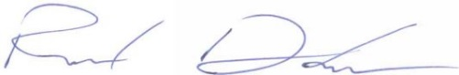
Richard Donelson
Project Manager / Estimator
LEED® Green Associate
richd@owpllc.net
425-591-4296 cell

